Bi-weekly Assignment 1&2 Report

Name: Kriti pradhan
Level-3
Section-’c’
Module: Fundamentals of Data Science
PART 1: Python Expressions
Expression 1: Perimeter of a rectangle
Calculates the perimeter using 2 * (length + width).
Expression 2: String with punctuation
Prints a string with punctuation: 'Python is great, it’s wild!'.
Expression 3: Power Operation
Calculates 2 to the 10th power using 2 ** 10.
Expression 4: Factorial Difference
Finds the difference of 7! - 5! using math.factorial.
Expression 5: Name multiplied
Multiplies the name 'Kriti' by 5.
Expression 6: Left justified string
Description: Justifies the name 'Kriti’' to the left with 15 spaces.
Expression 7: PI to 5 decimals
Displays PI up to 5 decimal places using round().
Expression 8: Modulus Operation
Finds 200 % 12.
Expression 9: Convert Float to Int
Converts 7.2 to integer using int().
Expression 10: Unicode encoding
Displays Unicode values for each character in 'Kriti' using ord().
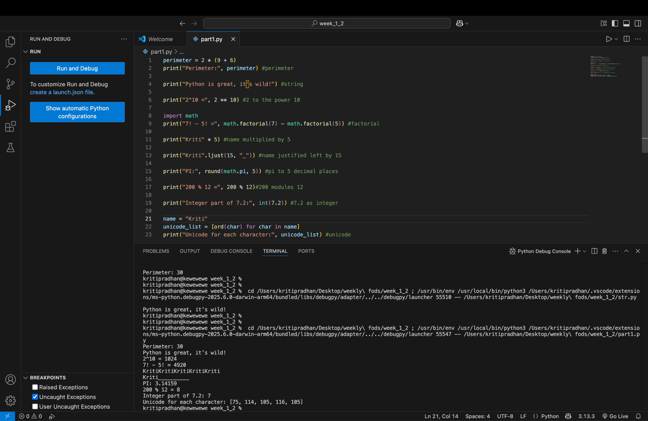
PART 2: Python Programs
Program 1: Even or Odd
Takes an integer input and checks if it's even or odd.
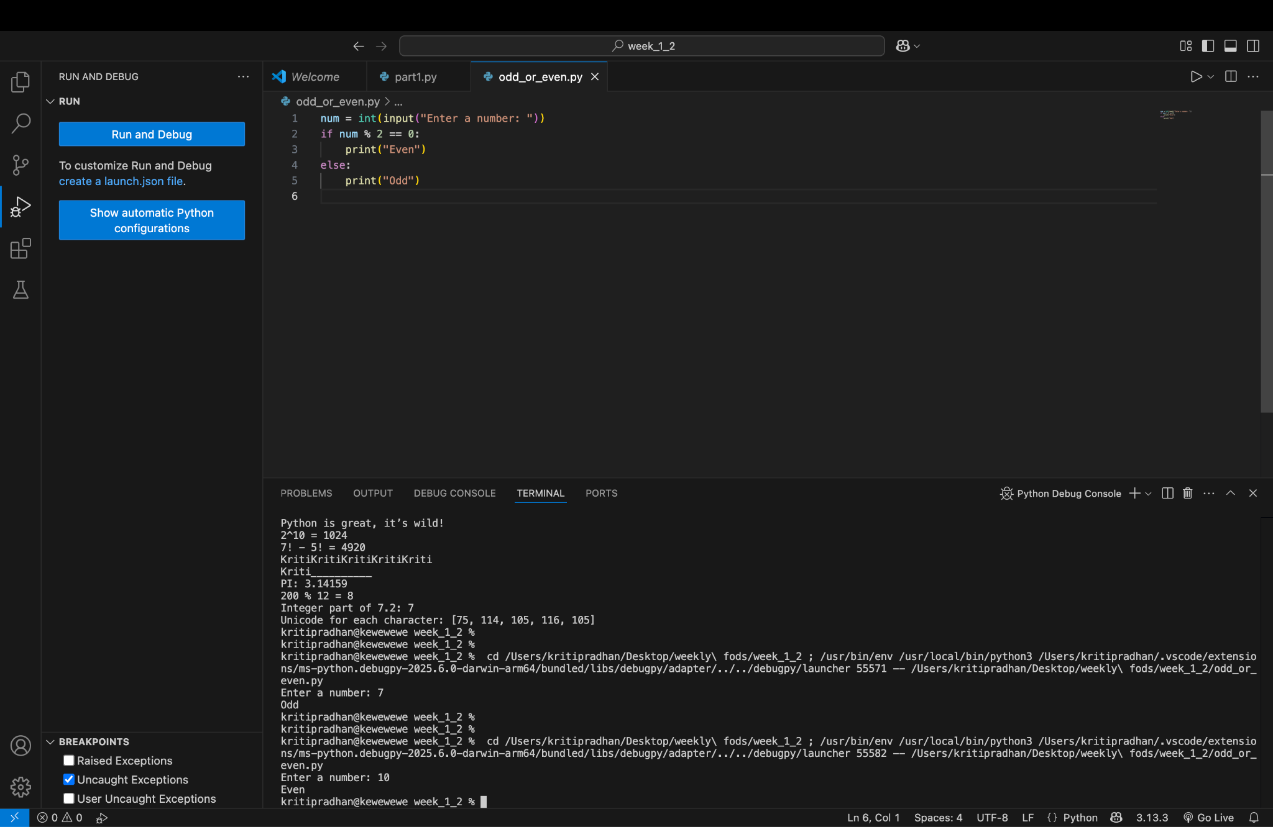

Program 2: Divide with Precision
Takes two integers, divides them, and shows the result with 2 decimal places.
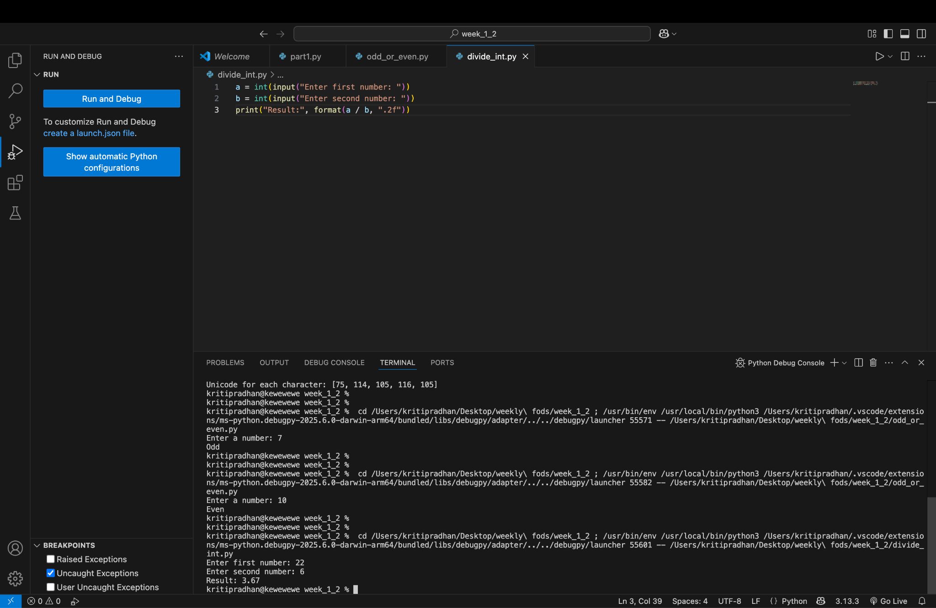
Program 3: Celsius to Fahrenheit
Converts Celsius temperature to Fahrenheit.
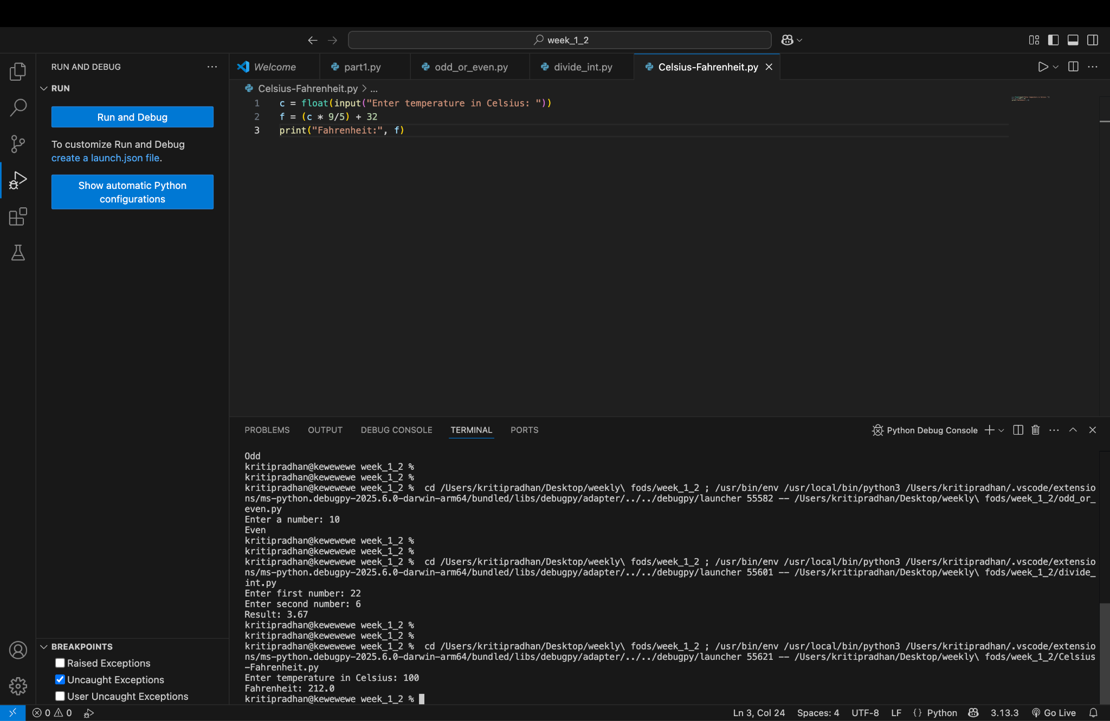

Program 4: Euclidean Distance
Calculates distance between two (x, y) coordinates.
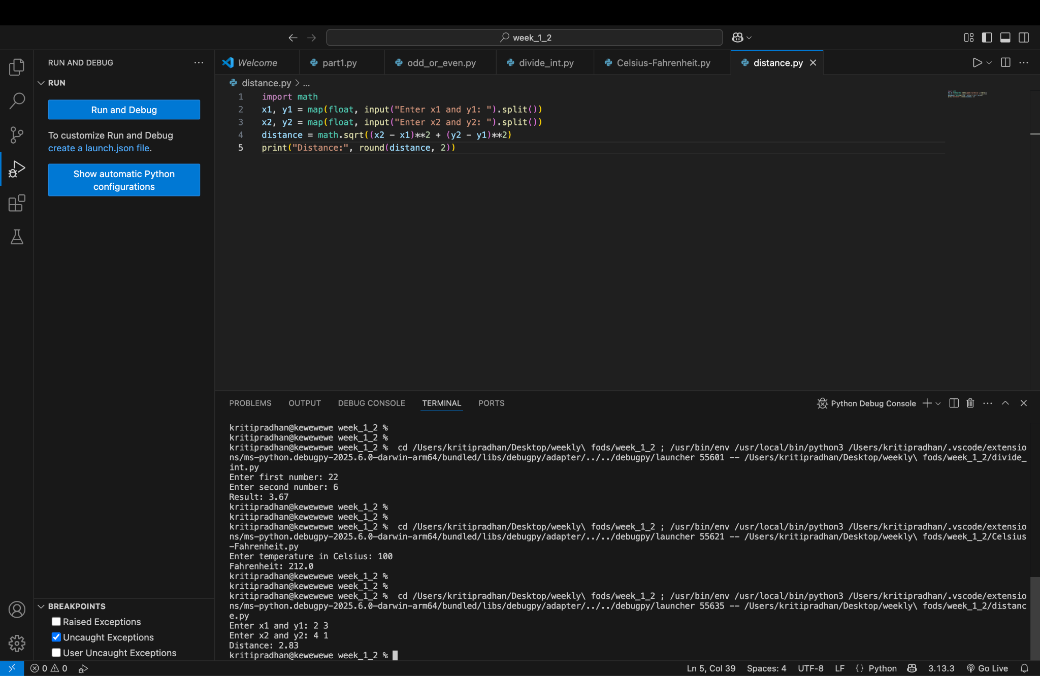
Program 5: Simple Interest
Calculates simple interest given principal, rate, and time.
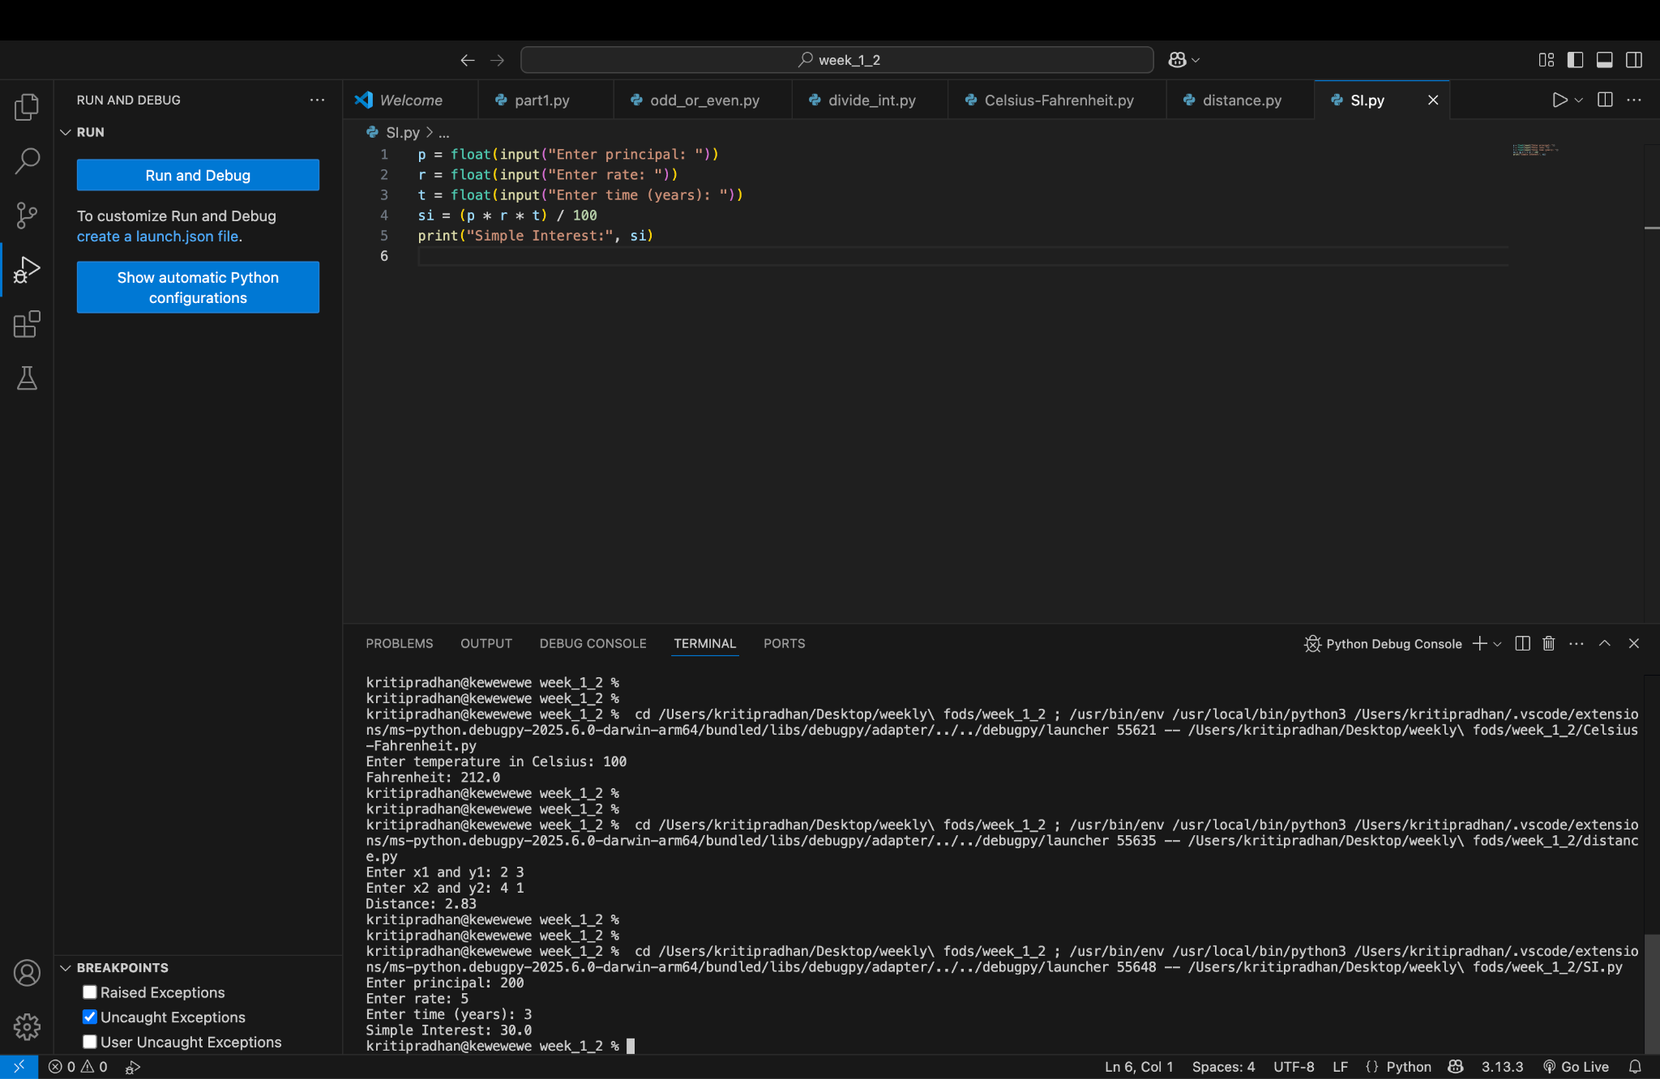

Program 6: Divisible by 7 and Multiple of 5
Finds numbers between 1500 and 2000 that satisfy both conditions.
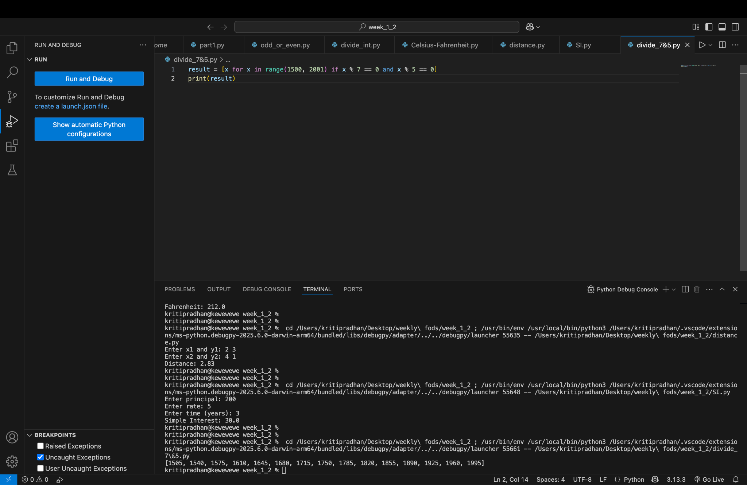
Program 7: Count Digits and Letters
Counts how many letters and digits are in a string.
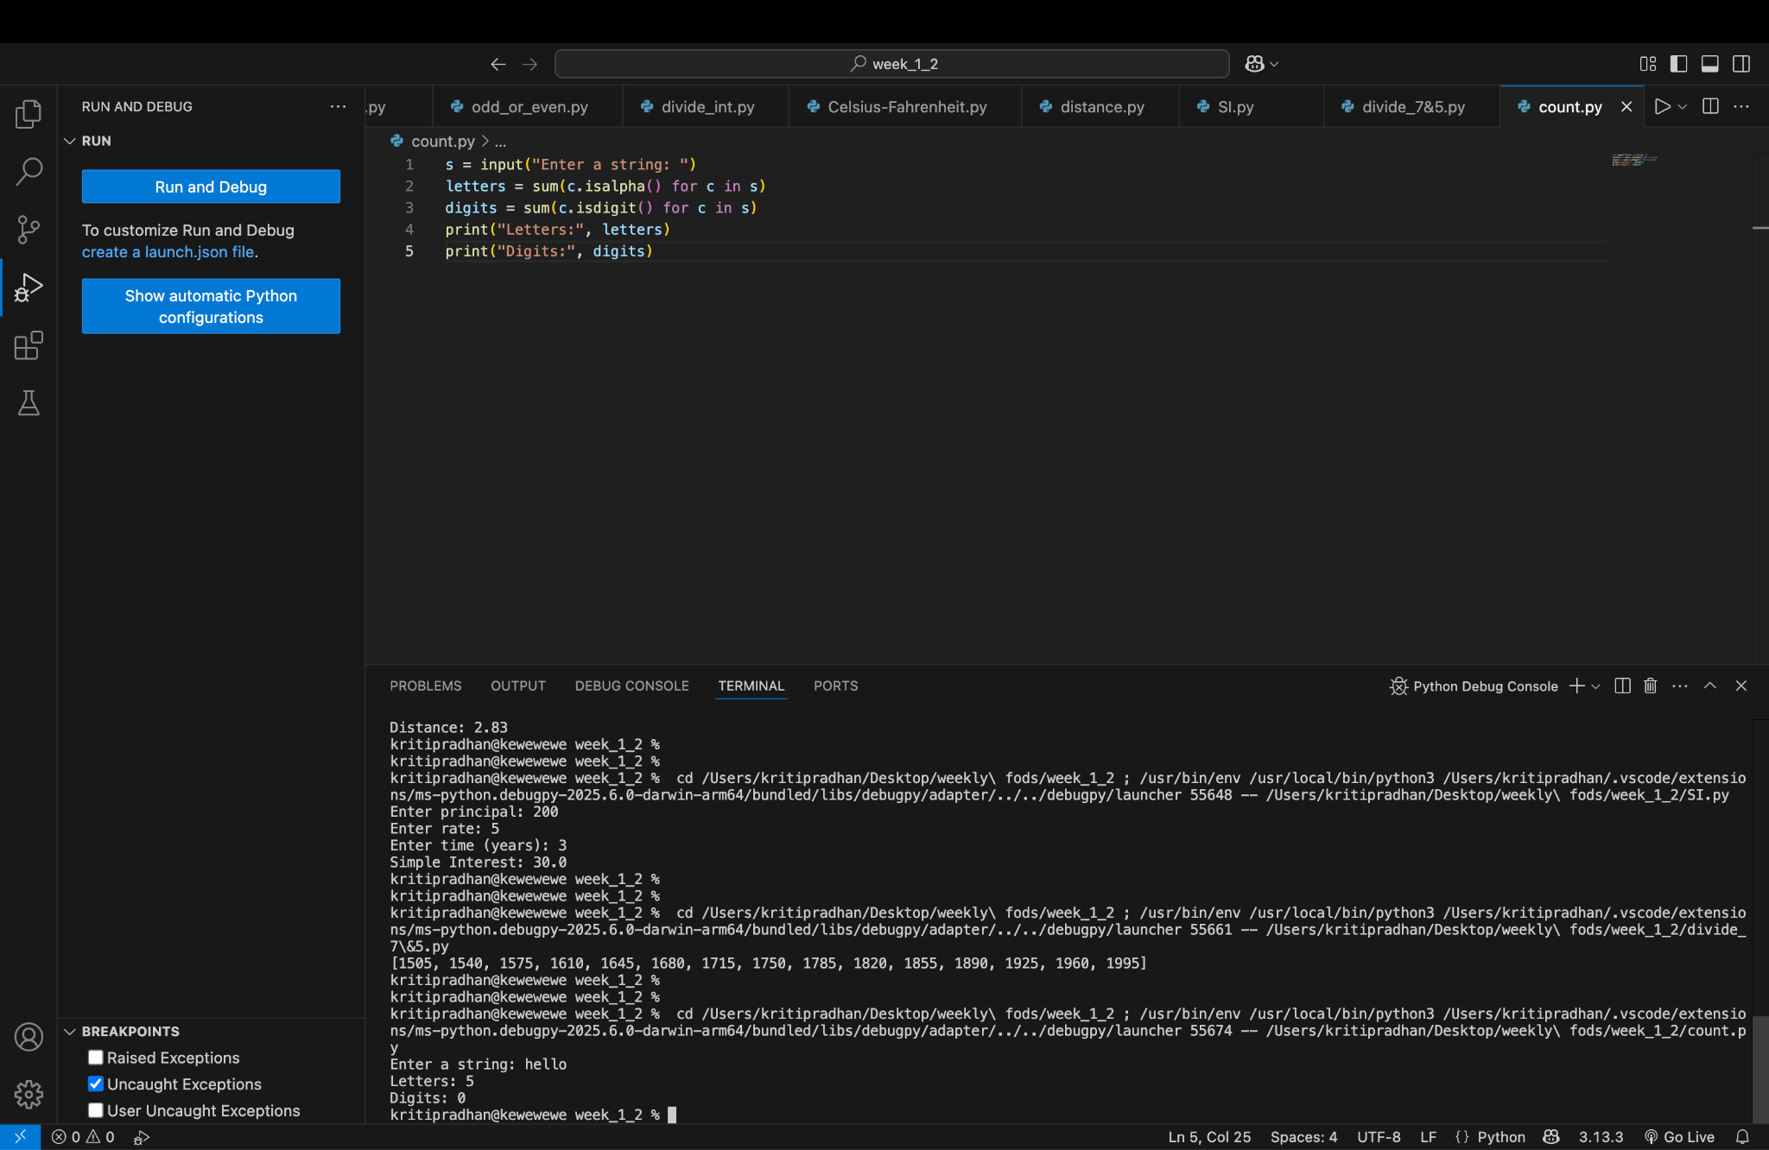

Program 8: Number Guessing Game
Allows users 5 chances to guess a random number with feedback.
